DE–5987
11
DISTANCE EDUCATION
M.Sc. (Physics) DEGREE EXAMINATION, MAY 2009.
CLASSICAL AND STATISTICAL MECHANICS
(2008 onwards)
Time : Three hours Maximum : 100 marks
Answer any FIVE questions.
Each question carries 20 marks.
1. (a) Derive Lagrange’s equations of motion from D’Alembert’s principle for conservative and non-conservative system. (9)
(b) Define generalised co-ordinates and obtain expression for
(i) Generalised force and
(ii) Generalised potential. (7)
(c) Obtain Lagrange’s equation of motion for a simple pendulum. (4)
2. (a) State and prove the principle of least action. (8)
(b) Explain any two conditions for a transformation to be canonical. (6)
(c) Show that the transformation 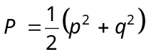, 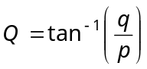 is canonical. (6)
3. (a) Explain stable and unstable equilibria. (4)
(b) Explain the normal co-ordinates and normal frequencies of vibration. (4)
(c) Apply to the case of a linear triatomic molecule and give explanation to the vibrations. (12)
4. (a) Explain the Euler’s angles through three successive rotatory operations. (6)
(b) Explain precession and nutation. Briefly explain the motion of a symmetric top under the action of gravity. (10)
(c) Obtain the three Euler’s equations for the motion of a rigid body with one point fixed. (4)
5. (a) Derive Hamilton-Jacobi equation for Hamilton’s characteristic function w. (6)
(b) Solve Kepler’s problem by H.J. method. (10)
(c) Explain the equations of motion in Poisson bracket form. (4)
6. (a) Explain what is meant by an ensemble. Discuss and compare micro canonical, canonical, and grand canonical ensembles. Mention uses. (4)
(b) State and prove Liouville’s theorem. (12)
(c) State and explain the two conditions for an ensemble to be in statistical equilibrium. (4)
7. (a) State and prove the theorem connecting entropy and probability. (4)
(b) Explain how it is used to calculate the entropy of a monoatomic gas. (6)
(c) Derive thermodynamic functions :
(i) Helmholtz free energy and
(ii) Entropy for canonical ensemble. (10)
8. (a) Explain partition function. (3)
(b) Express thermodynamical quantities such as energy E, Helmholtz free energy F, entropy S and specific heat C_{V} in terms of partition function. (11)
(c) Calculate mean, root mean square and most probable velocities from the expression of Maxwell’s distribution of velocities. (6)
————————
DISTANCE EDUCATION
DE-5991
15
M.Sc. (Physics) DEGREE EXAMINATION, MAY 2009.
NUMERICAL METHODS AND PROGRAMMING
(2008 onwards)
Time : Three hours Maximum : 100 marks
Answer any FIVE questions.
Each question carries 20 marks.
1. (a) Give the general structure of a C-program.
(b) What are the various constants associated with
c-program? Explain.
(c) Explain printf statement in detail.
2. (a) What are unary operators? Explain.
(b) Explain the use of if else statement in C-program.
(c) With suitable example give a detailed account on the switch statement.
3. (a) How is a structure defined and used?
(b) Write a C-program for finding the factorial of a number using recursive function.
(c) Give an account on opening and closing of a data file.
4. (a) Derive the formula for Newton-Raphson method for finding the roots of an equation.
(b) Write a c-program to solve the equation 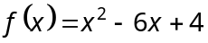 by Newton-Raphson method.
(c) Give an account on bisection method of finding the roots of an equation. State its demerit.
5. (a) Explain the principle of Gauss elimination method.
(b) Discuss Gauss Siedal iterative methods of solving linear equation.
(c) By Gauss elimination method solve the following equations
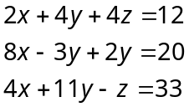
6. (a) What are the advantages of using central differences in interpolation?
(b) Use String’s formula to find 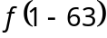 given that
x : | 1.5 | 1.6 | 1.7 | 1.8 | 1.9
f (x) : | 17.609 | 20.412 | 23.045 | 25.527 | 27.875
(c) Using least squares fit a parabola for the given data.
x : | 0 | 2 | 4 | 6 | 8 | 10
y : | 1 | 3 | 13 | 31 | 57 | 91
7. (a) Discuss the Trapezoidal rule for solving a solution of an integral.
(b) Obtain Simpson’s one third rule.
(c) Using Simson’s rule, evaluate 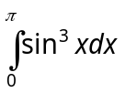 taking the internal of 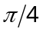.
8. (a) Obtain Euler’s modified formula.
(b) Discuss second-order Runge-Kutta method for finding the solutions of an equation.
(c) Solve the differential equation
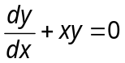 with 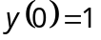 from 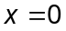 to 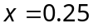 using Euler’s method.
———————
DISTANCE EDUCATION
DE–5990
14
M.Sc. (Physics) DEGREE EXAMINATION, MAY 2009.
ELECTROMAGNETIC THEORY
(2008 onwards)
Time : Three hours Maximum : 100 marks
Answer any FIVE questions.
Each question carries 20 marks.
1. (a) Discuss the propagation of plane electromagnetic wave in an isotropic medium. (8)
(b) Show that field vectors E and H are in same phase.
(4)
(c) Show that the flow of energy is along the direction of propagation of electromagnetic wave. (8)
2. (a) Write the Maxwell’s equations in differential form.
(6)
(b) Write the Integral form of Maxwell’s equation. (4)
(c) State and explain Poynting theorem from electromagnetic theory. (10)
3. Derive the Fresnel’s equation for reflection and refraction of electromagnetic waves at a plane boundary separating two dielectric media. (20)
4. (a) Explain scattering parameters. (4)
(b) Write a note on polarization by scattering. (6)
(c) Obtain Thomson scattering cross section in the case of scattering of electromagnetic waves by a free electron. (10)
5. (a) Explain the microwave generation :
(i) Klystron. (10)
(ii) Magnetron. (6)
(b) Explain the principle and working of a Gunn diode.
(4)
6. Explain the following :
(a) Rectangular wave guides (8)
(b) Cylindrical wave guides. (8)
(c) Principle of operation of wave guides (4)
7. (a) Describe the magnetohydrodynamics (12)
(b) Briefly explain magnetic confinement (4)
(c) Explain the instabilities in pinched plasma (4)
8. (a) Discuss the theory of plasma waves (10)
(b) What do you mean by Debye length? (4)
(c) Explain plasma oscillations (6)
———————
DISTANCE EDUCATION
DE–5989
13
M.Sc. (Physics) DEGREE EXAMINATION, MAY 2009.
INTEGRATED AND DIGITAL ELECTRONICS
(2008 onwards)
Time : Three hours Maximum : 100 marks
Answer any FIVE questions.
Each question carries 20 marks.
1. (a) Explain the difference between a voltage and power amplifier. (5)
(b) With a neat circuit describe the working of class B power amplifier. (10)
(c) Calculate the efficiency of class B Amplifier. (5)
2. (a) Explain Miller’s theorem for transformation. (8)
(b) Write a note on a tuned amplifier. (4)
(c) Explain the performance of a transformer coupled audio power amplifier. (8)
3. (a) Explain the characteristics of an ideal operational amplifier. (5)
(b) Discuss how the slew rate affect the a.c. operation of OP-Amp. (5)
(c) Describe how analog computation is done by
Op-Amp with suitable example. (10)
4. Discuss the use of OP-Amp as
(a) Integrator (7)
(b) Non inverting amplifiers. (6)
(c) Explain the operation of XOR gate with suitable truth table. (7)
5. (a) Discuss about RS flip flop using NOR gates. (6)
(b) Use the Boolean algebra and simplify the equation 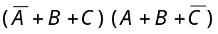. Draw the corresponding logic circuit. (7)
(c) Explain the action of Master Slave JK flip flop. (7)
6. (a) Explain the working of OP-Amp as difference amplifier. (4)
(b) State and explain any 6 laws of Boolean algebra. Give examples. (6)
(c) Describe the operation of serial in serial out shift register. (10)
7. (a) Give a block diagram showing the internal architecture of 8086 microprocessor. (6)
(b) Explain the functions of different blocks. (10)
(c) Write about any four major groups of instruction set of 8085 microprocessor. (4)
8. (a) Discuss the various steps to fabricate a monolithic circuit. (10)
(b) Explain the construction and working of a solar cell.
(8)
(c) Give the uses of solar cell. (2)
———————
DISTANCE EDUCATION
DE-5988
12
M.Sc. (Physics) DEGREE EXAMINATION, MAY 2009.
MATHEMATICAL PHYSICS
(2008 onwards)
Time : Three hours Maximum : 100 marks
Answer any FIVE questions.
Each question carries 20 marks.
Question A and B will carry 5 marks each and Question C will be awarded with 10 marks.
1. (a) Show that the eigen values of a Hermitian matrix are all real.
(b) Find the eigen values of the following matrix :
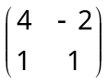.
(c) Determine the eigen values and eigen vectors of matrix 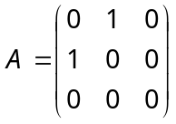 and verify the orthogonality of its eigen vectors.
2. (a) Prove that the diagonalizing of a real symmetric matrix is orthogonal.
(b) Define vector space. Discuss addition of vectors.
(c) State and prove Cayley-Hamiltonian theorem.
3. (a) State and prove Rodrigue's formula of Legendre polynomial.
(b) Prove 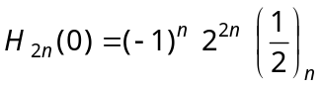.
(c) Express the relation between Beta and Gamma Function.
4. (a) Explain the linearity property of
Laplace transforms.
(b) Find the Laplace transform of 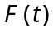 given by
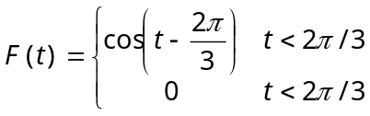
(c) Expand the Fourier transform of square waves
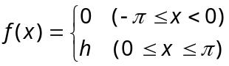
5. (a) Explain Parseval's theorem.
(b) Using Cauchy's integral formula, calculate the integral
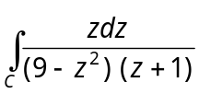 were C is the circle 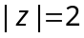 described in the positive sense.
(c) State and prove Cauchy's Residue theorem.
6. (a) Determine the two-dimensional wave-equation for a rectangular membrane.
(b) Determine the one-dimensional wave equation for transverse waves in a flexible string of uniform mass per unit length.
(c) Determine the solution for Laplace's equation in Cartesian co-ordinates.
7. (a) If 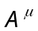 and 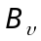 are the components of a contravariant and co-variant tensors, show that 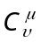 = 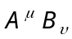 are the components of a mixed tensor of rank two.
(b) Determine the equations of motions for the moment of inertia tensor of a rigid body.
(c) Show that a finite group may be written as a sum of particular sub-group and its finite number of cosets.
8. (a) Express the product 2.5.8.... (3n – 1) in terms of Gamma functions.
(b) Show that  is an analytic function of complex variable 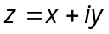.
(c) Prove 



